Schedule “A”
Project Plan

- Background

<This section should provide the concept for the line and provide a name for the array>

- Initial Array Design
- Equipment and Services:
Dalhousie will provide:
      - XX acoustic receivers:
      - XX acoustic releases:

partner will provide:
      - <Moorings?>…..
      - <Boat time for initial deployment?>
      - <Qualified personnel for initial deployment?> (including divers if necessary)
      - <Boat time for maintenance and uploading of data?>.
      - <Qualified personnel for initial deployment?>
      - <Replacement batteries for acoustic receivers?>.
      - <Range testing boat time with dedicated technical staff.

- Proposed Line Location:

Sample text: The <array name here> will be located <general description of the array with reference to any well known landmarks>. The line is composed of <X> stations (See maps below). Details of the deployment geometry (spacing between stations and depth of receivers) are for illustrative purpose as changes might be required upon analysis of the test phase data.

Sample map:
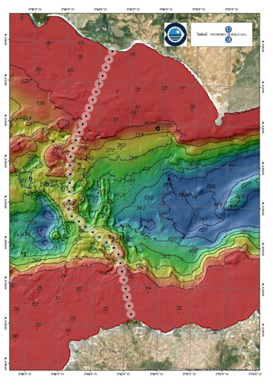

- Bathymetry Information:

<This section should provide any available information on bathymetry. A sample diagram is shown below>
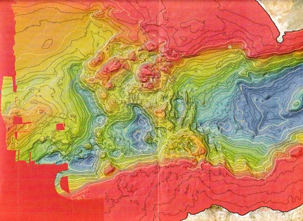
- Proposed Receiver Locations:
    - These proposed receiver locations are approximations and are subject to change.
<This information can be keyed into this spreadsheet located at:>
http://www.marinebiodiversity.ca/OTN/data/data-collection/data-sheet-templates/station-locations-v1.0.xls/view

- Deployment Schedule

The deployment of the <X> acoustic receivers is planned for <relative timeframe.. exact dates not required>. Final details of the deployment schedules are still being reviewed and will depend on vessel availability and weather conditions.

- Maintenance Schedule

It is expected that service trips to the <name of the array> will take place (at a minimum) once a year, at which time batteries will be changed if needed in the receivers and acoustic releases, and biofouling will be removed from the receivers and acoustic releases. Maintenance checks and upgrades (at a minimum batteries and corroded parts will be replaced, where applicable, full replacement units will be provided) will be performed during those trips. It is expected that during maintenance trips, equipment at each station will be recovered, maintained and redeployed in a timely manner as to avoid any prolonged absence of acoustic receivers on the acoustic array.

- Data Retrieval Schedule

Data will be uploaded from the receivers once a year, and submitted to OTN in the manner outlined in the OTN Data Management Policy.

- Mooring Design

<This section should provide details of the Mooring design where required>.

- Shipping Details

Dalhousie University will cover costs of shipping the equipment to <location where equipment will be shipped/delivered>. Dalhousie will ensure that the acoustic receivers are in good working order and condition before they are shipped.

To expedite shipping, it is critical to provide the following information:

The name and contact information of your customs broker:
The shipping address:
Your fax#:
Your telephone#:

- Roles and Responsibilities

<To be completed by OTN staff>

- Receiver Replacement

<To be completed by OTN staff>

- Risk Management

<To be completed by OTN staff>

