OTN - Project Plan

Name of Array

Created: | January 12, 2011
Version: | 1.0

Table of Contents

1. Background 3
2. Initial Array Design 3
3. Deployment Schedule 6
4. Maintenance Schedule 6
5. Data Retrieval Schedule 6
6. Mooring Design 6
7. Shipping Details 6
8. Roles and Responsibilities 6
9. Receiver Replacement 7
10. Risk Management 7

Background

<This section should provide the concept for the line and provide a name for the array>

Initial Array Design
- Equipment and Services:
    - Dalhousie will provide:
      - XX acoustic receivers: with lithium batteries;
    - partner will provide:
      - <Ship time>
      - <Qualified personnel for deployment>
      - <Boat time for maintenance and uploading of data>.
      - <Replacement batteries for acoustic receivers?>.

- Proposed Line Location:

Sample text: The <array name here> will be located <general description of the array with reference to any well known landmarks>. The line is composed of <X> stations (See maps below). Details of the deployment geometry (spacing between stations and depth of receivers) are for illustrative purpose as changes might be required upon analysis of the test phase data.

Sample map:
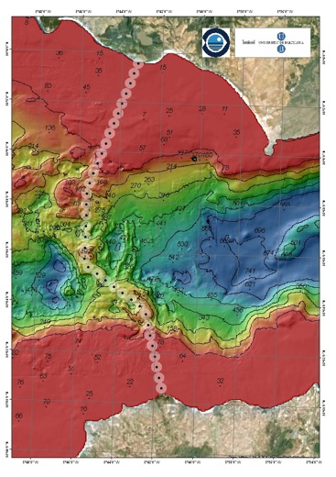

- Bathymetry Information:

<This section should provide any available information on bathymetry. A sample diagram is shown below>
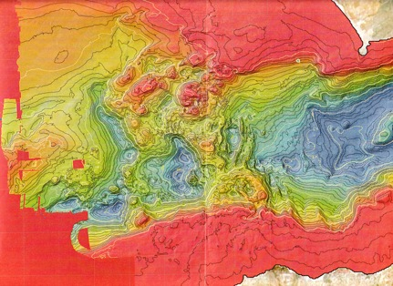
- Proposed Receiver Locations:
    - These proposed receiver locations are approximations and are subject to change.
<This information can be keyed into this spreadsheet located at:>
http://members.oceantrack.org/data/data-collection/data-sheet-templates/station-locations/view)

Deployment Schedule

The deployment of the <X> acoustic receivers is planned for <relative timeframe.. exact dates not required>. Final details of the deployment schedules are still being reviewed and will depend on vessel availability and weather conditions.

Maintenance Schedule

It is expected that service trips to the <name of the array> will take place (at a minimum) once a year, at which time batteries will be changed and biofouling will be removed.

Data Retrieval Schedule

Data will be uploaded from the receivers once a year, and submitted to OTN in the manner outlined in the OTN Data Management Policy.

Mooring Design

<This section should provide details of the Mooring design where required>.

Shipping Details
Dalhousie University will cover costs of shipping the equipment to <location where equipment will be shipped/delivered>. Dalhousie will ensure that the acoustic receivers are in good working order and condition before they are shipped.

Please provide the complete shipping address for your institution.

Please provide the name and contact information for your broker including email address, fax and telephone number.

Roles and Responsibilities

<To be completed by OTN staff>

Receiver Replacement

<To be completed by OTN staff>

Risk Management

<To be completed by OTN staff>

Institution Name:  By:  Title:  Signature:  _____________________________ | DALHOUSIE UNIVERSITY  By:  Title:  Signature:  ____________________________

