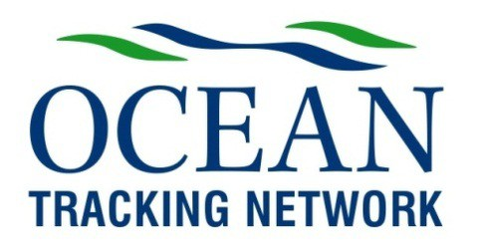

**Ocean Tracking Network Council Meeting**

Monday, November 3rd, 2014

13:00 – 15:00 AST

Location: Teleconference

Invitees: Peter Harrison, Bill Casey, Martha Crago, Albert Fischer, Dave Gillis, Jim Hanlon, Beth Hunter, Nigel Lloyd, Chris Moore, Leo Muise, Christine Penney, Zdenka Willis, *Doug Wallace, Nancy Hayter, *Kes Morton, *Amy Ryan *Fred Whoriskey, *Sara Iverson (non-voting, *staff)*

Regrets:

**Agenda**

13:00 - 13:05 Welcoming of new members

13:05 - 13:10 Call to Order, review and adoption of Minutes of the last Council Meeting

13:10 - 13:15 Agenda approval (P. Harrison)

13:15 - 13:20 Chair’s welcome and remarks (P. Harrison)

13:20 - 13:50 OTN Senior Management Report (F. Whoriskey and S. Iverson)

13:50 - 14:20 Future Funding Opportunities

14:20 - 14:30 Next meeting (P. Harrison)

14:30 - 15:00 Other business

15:00 Conclusion

**Mercuri Conferencing Call-In Information**

1. Dial 1-800-808-0861 on a conferencing phone or speaker-phone enabled handset.

2. Enter the participant code (Dalhousie’s participant number is 712443).

3. Speak your name at the prompt and you will be entered into the conference call.

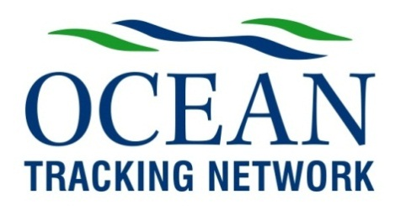

s

# OTN Council Terms of Reference

**Mandate**

The Council provides independent, external stewardship of the OTN on behalf of Dalhousie University and all other OTN stakeholders. The Council has responsibility for:

* *Strategic direction* - Approve the strategic direction and annual management plans for the OTN.
* *Strategic positioning* - Advise on the OTN’s identity, its image, and the way it needs to position itself for success, including the provision of advice on new funding opportunities.
* *Financial* - Recommend to the OTN Executive and the Liaison Committee the annual budget and the budgets for any major upgrades.
* *Oversight of performance* - Monitor the deployment and performance of the OTN platform, the extent of international collaboration and the scientific output.
* *Risk management* - Ensure that there are procedures and controls in place to effectively monitor and manage risks.
* *Linkages:*
  + ensure that the OTN is coordinating and collaborating in its activities with appropriate initiatives, both nationally and internationally.
  + facilitate interactions between OTN stakeholders and receptors and end-users of knowledge products
* *Advice* - Provide feedback on new ideas and proposed developments
* *Approvals of:*
  + the recommendations of the Deployment Committee and International Scientific Advisory Committee, as appropriate
  + the Terms of Reference for the OTN Council, and its associated committees

The Council will typically meet three times a year, either in person or by teleconference.

**Membership**

The members of the Council are appointed by the President of Dalhousie University, and serve a three year term (renewable).The Council will consist of up to 12 members with relevant skills and experience, drawn from academia, government, and industry.

**Chair**

The Chair of the Council is appointed by the President of Dalhousie University.

The Chair presides at meetings of the Council, makes sure that decisions taken by the Council are consistent with applicable OTN and Dalhousie University Policies, works with the Principal Investigator and Executive Director to provide a bridge between the OTN Council and staff, and monitors the implementation of OTN Council decisions. The term of the Chair is three years (renewable).

## OTN Council Membership

(**chair**, **voting**, *non-voting*, \**staff*)

|  |  |
| --- | --- |
| **Name** | **Institution and Position** |
| **Peter Harrison** | Queens University |
| **Bill Casey** | Former Head, NS Government Office, Ottawa |
| **Martha Crago** | VP Research, Dalhousie |
| **Albert Fischer** | Head, Ocean Observations and Services Section, International Ocean Committee, UNESCO |
| **Trevor Swerdfager** | Director General, Ecosystems and Oceans Science Sector, Department of Fisheries and Oceans |
| **Jim Hanlon** | CEO, Halifax Marine Research Institute; Chair, Value Proposition for Irving Shipbuilding Procurement |
| **Beth Hunter** | Former CEO, McConnell Foundation (resigned October 2013) |
| **Nigel Lloyd** | Former Executive VP, NSERC |
| **Chris Moore** | Dean of Science, Dalhousie |
| **Leo Muise** | Former NS Fisheries and Aquaculture (retired January 2014) |
| **Christine Penney** | VP, Clearwater Seafoods |
| **Zdenka Willis** | Director, International Ocean Observing System, NOAA |
| *Nancy Hayter* | Director, Research Grants and Contracts Dalhousie |
| *\*Sara Iverson* | OTN Scientific Director |
| *\*Kes Morton* | OTN Senior Project Manager |
| *\*Amy Ryan* | OTN Canada Network Manager (acting) |
| *Doug Wallace* | Canada Excellence Research Chairs |
| *\*Fred Whoriskey* | OTN Executive Director |

*Biographies not included at this time: Trevor Swerdfager*

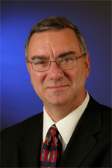**Peter Harrison**

Dr. Peter Harrison is Professor, Stauffer-Dunning Chair and Director of the School of Policy Studies (SPS) at Queen’s University (Kingston, Ontario). His career as a senior member of the Public Service of Canada lasted nearly 30 years. During this time he served as the Deputy Minister (Permanent Secretary) of a number of federal Departments including Natural Resources Canada, the Department of Fisheries and Oceans, the Leadership Network, the National Research Council of Canada (Senior Research Fellow, Oceans) and Indian Residential Schools Resolution Canada. Dr. Harrison’s research, writing and teaching focus on ocean and coastal management/northern development with particular reference to the Arctic Ocean and Arctic/northern policy. He was the international co-chair of the China Council for International Co-operation on Environment and Development (CCICED) Task Force on the Sustainable Use of China’s Ocean and Coasts.

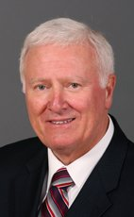**Bill Casey**

Bill Casey is a graduate of St. Francis Xavier and holds a Bachelor of Science and Engineering Diploma. Prior to his political career, Bill Casey was involved in many business ventures. He was first elected to the House of Commons in 1988. After the 1993 election he returned to his business career and became a Financial Advisor and Stock Broker with Merrill Lynch. In 2000, Bill Casey was re-elected and appointed critic for Foreign Affairs and International Trade where he acted not only as an Opposition critic, but also as an activist for diplomacy in troubled regions of the world. He was later appointed Deputy Whip of the Conservative Party of Canada. In June of 2004, Mr. Casey was re-elected and was sent back to the House of Commons following the January 2006 election.

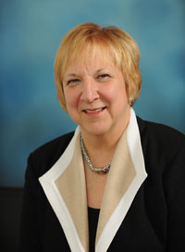**Dr. Martha Crago**

Martha Crago is the Vice President (Research) and Professor in Human Communication Disorders at Dalhousie University. Her previous university administrative positions include Vice Rector (International and Governmental Relations) at the Universite de Montreal, the Dean of Graduate and Postdoctoral Studies and Associate Provost (Academic Programs) at McGill University.

She has served as President of the Canadian Association for Graduate Studies, a member of the University Advisory Group at Industry Canada, and as a board member for the Council of Graduate Schools (USA). Dr. Crago is presently on the boards of World Learning as well as the Nova Scotia Carbon Capture and Storage Research Consortium of Nova Scotia and the Advisory Councils of the Department of Fisheries and Oceans of Canada and the National Research Council-Institute of Marine Biosciences. At Dalhousie University, she chairs a variety of research institutes governing councils and committees. Martha Crago is an active member of the Vice Presidents (Research) of the G13 research intense universities of Canada, and the Vice Presidents (Research) Group of the Atlantic Association of Universities.

Dr. Crago has been an active researcher in language acquisition. She has published her research extensively in scientific journals and books and is the Editor-in-Chief of Applied Psycholinguistics published by Cambridge University Press. She presently serves as Vice President of the International Association for the Study of Child Language

Dr. Crago was named Chevalier in l’ordre des Palmes academiques by the government of France in 2009.

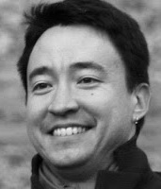**Dr.** **Albert Fischer**

Dr. Albert Fischer is a physical oceanographer and climate modeler by training, and has been working in the Global Ocean Observing System Project Office since 2004. He has a Ph.D. from the MIT / Woods Hole Oceanographic Institute Joint Program in Oceanography, and worked as a researcher at the Université Pierre et Marie Curie (Paris).

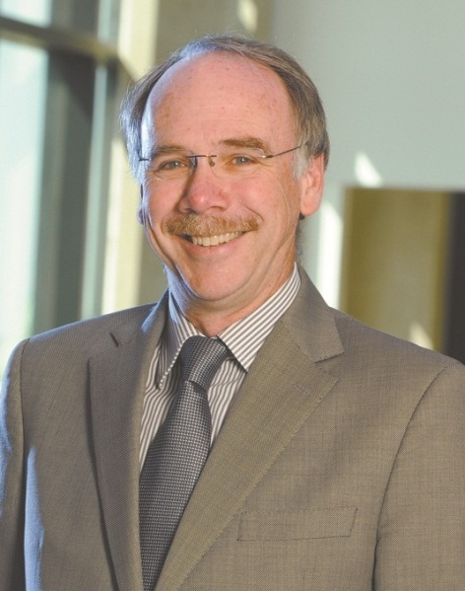**Jim Hanlon**

Chief Executive Officer, Halifax Marine Research Institute (HMRI) (Halifax, NS)

Jim is a 30-year veteran of the Canadian tech industry, having worked in design, marketing and management for companies in Atlantic Canada, Ontario and New England. His career has spanned the aerospace and defence sectors as well as the marine environmental monitoring field. Over the years Jim has worked in senior management positions with several large publicly traded multinationals but he has also sampled the waters of the entrepreneurial well as an owner in two separate high tech companies that have successfully grown and been purchased by multinationals.

Until February of 2012, Jim was the President of Ultra Electronics Maritime Systems in Halifax. He and his partners sold their company to Ultra in May of 2008. Ultra Electronics Marine Systems is one of the oldest continuously operating electronics design and manufacturing operations in Canada and the largest electronics product design company in Atlantic Canada.

In May of 2012, Jim assumed the role of CEO of the Halifax Marine Research Institute, a not- for-profit company established to foster collaborative ocean research among universities, government labs and private companies.

Jim’s personal passion is innovation and its impact on the competitiveness of Canadian industry.

Jim is a proud alumnus of Nova Scotia Technical College (now Dalhousie University Faculty of Engineering) with a degree in electrical engineering. He also has an MBA in marketing from Saint Mary’s University in Halifax and he is a registered professional engineer in Nova Scotia.

Jim and his wife Anne have three children and enjoy boating and life on the water in Nova Scotia!

**Beth Hunter**

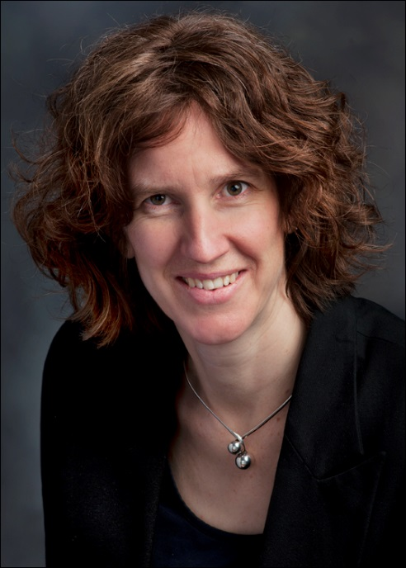Beth Hunter has been Senior Program Officer with the J.W. McConnell Family Foundation since 2010 and currently leads the Sustainable Food Systems initiative as well as an emerging initiative on Energy and the Economy. She holds a BA from the Liberal Arts College of Concordia University (Montreal) and an MSc in Rural Economics from Université Laval (Quebec City). Her Masters research focused on food security and dietary diversity in rural Lebanon. She is a co-founder of Equiterre, one of Canada's environmental organizations, where she coordinated the sustainable agriculture program. She led Greenpeace Canada’s Oceans campaign from 2007-2010, working with major Canadian supermarkets to develop sustainable seafood policies and practices. She has authored numerous articles, reports and guides, including Hungry for Justice: A Montreal Guide to Socially Responsible Food Choices, and a guide to Community Supported Agriculture.

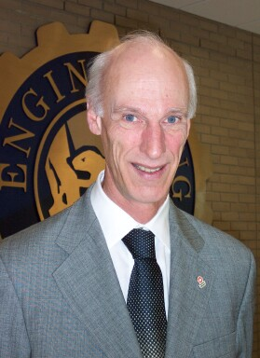**Nigel Lloyd**

Nigel Lloyd is a plant scientist recently retired after a long career at NSERC (Natural Sciences and Engineering Research Council).

Educated in England, with a degree in Natural Sciences from Cambridge University, and a Ph.D. in Physiological Ecology from the University of Leeds, Nigel came to Canada in 1974 as a postdoctoral fellow at Queen’s University. After two years at Queen’s, and a further two years at Carleton University, Nigel joined a small seaweed company, Genu Products Ltd, in Halifax, Nova Scotia, and became Chief Scientist for their aquaculture project to grow Irish Moss.

In 1981 Nigel moved to Ottawa to join NSERC as a Strategic Grants Officer with the Energy Panel. He moved steadily up the ranks, becoming Director General for Grants and Scholarships in 1991, and finally in 2003 was appointed to the new position of Executive Vice President, in which he remained until his retirement in 2009. He is married with two children and two grandchildren.

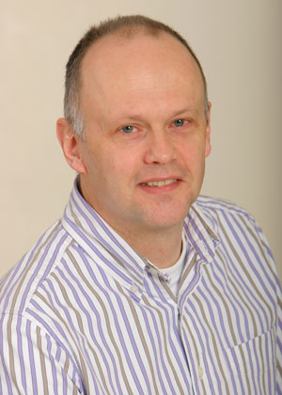**Chris Moore**

Dr. Chris Moore is the Dean of Science and a Professor of Psychology at Dalhousie University in Halifax. His main research interests are in the early development of social understanding. His empirical research cover the late infancy period (9 to 24 months) and the late preschool period (3-5 years). Chris Moore also has a side interest in evolutionary psychology.

**Leo Muise**

Leo Muise graduated from Saint Francis Xavier University in 1975. He began his career with the Department of Fisheries and Oceans as a fishery officer. He worked in the fisheries legislation section in Ottawa and managed the DFO regulatory and licensing units in Halifax.

In 1997 Leo assumed his present position of Director of aquaculture for the Province of Nova Scotia. The primary interest areas of aquaculture research for the Department of Agriculture & Fisheries include fish health, aquaculture production, new species development, production engineering, and environmental assessment and monitoring.

# 2014 MSC Website CPenney Head Shot USE THIS ONE.jpgChristine Penney

Christine Penney is Vice President of Sustainability and Public Affairs for Clearwater Seafoods Limited Partnership (CSLP), North America’s largest shellfish company and a global leader in sustainable wild seafood with global sales of over 380 million dollars.

With over 15 years of dedication at Clearwater, she is Clearwater’s first female executive. She has become a role model and mentor for many of the high potential women in the Clearwater organization.

Christine holds Bachelor of Science and Masters of Marine Management degrees from Dalhousie University in Nova Scotia. She plays a leadership role in global sustainability initiatives serving on the Board of Trustees for the Marine Stewardship Council, the Executive Committee for the global Association of Sustainable Fisheries and as a Fisheries Ambassador for Prince Charles Sustainability Unit, Marine Program.

Christine serves on the board of several industry associations such as the Canadian Association of Prawn Producers, the Seafood Producers Association of Nova Scotia and the Fisheries Council of Canada.

In 2012, she was awarded the Progress Club Halifax Cornwallis Woman of Excellence for her extensive contribution to the field of Communications and Public Relations.

Christine resides in Halifax, Nova Scotia with her husband and son.

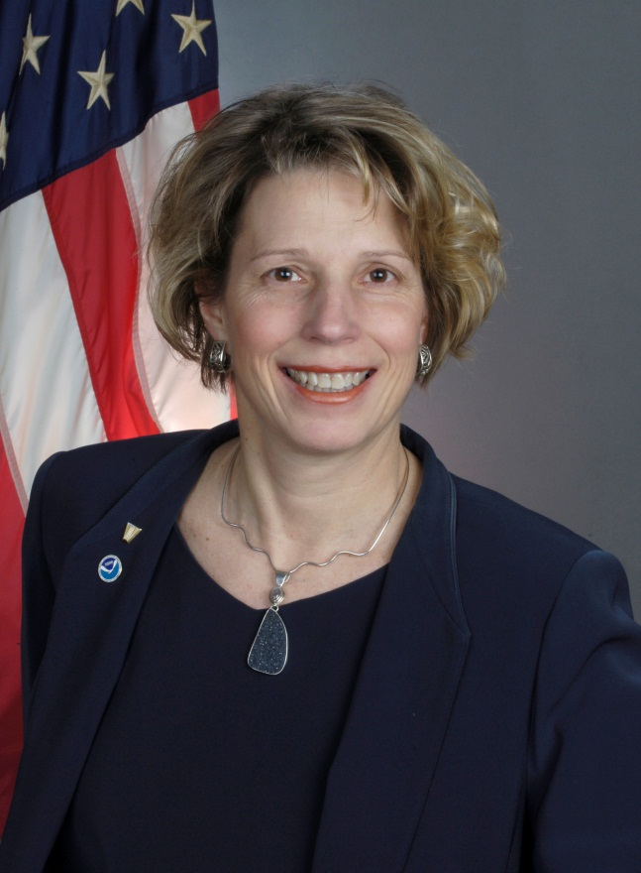**Zdenka Willis**

Zdenka Saba Willis, a member of Senior Executive Service, is the Director of the U.S. Integrated Ocean Observing System (IOOS®) Program. U.S. IOOS which is a coordinated network of people and technology that work together to generate and disseminate continuous data on our coastal waters, Great Lakes, and oceans.

Prior to her assignment as Director of U.S. IOOS Program, Ms. Willis served as Director of NOAA’s National Oceanographic Data Center. Ms. Willis is a retired Navy Captain with career service as a Meteorology and Oceanography officer in the United States Navy. She has promoted interagency cooperation as the Naval Deputy to NOAA; worldwide sea ice analysis and forecasting as Director of the National Ice Center; and as the satellite and operations officer Naval Polar Oceanography Center. While the Director of the National Ice Center initiated a visiting scientist program which attracted post-doctorate researchers focused on the Arctic and Antarctic. Her meteorological background include weather forecasting for Naval aircraft as the Officer in Charge of the Naval Oceanography Command Detachment, Oceana Virginia and for Navy vessels as the Naval Eastern Oceanography Center, Norfolk Virginia. Ms. Willis has a background in the collection of oceanographic data onboard the USNS Harkness and USNS Maury survey vessels and in the electronic navigational charting as Deputy Navigator of the Navy. Her other relevant Naval positions are the director of the Strategic Policy Forum (a Congressional and Executive Branch crisis simulation for Members of Congress, senior Executive branch officials, and military leaders) and adjunct professor in the Strategic Leadership Department at the Industrial College for the Armed Forces.

Ms. Willis received her Bachelor’s Degree in Marine Science from the University of South Carolina. She received a Master’s degree in Meteorology and Oceanography from the Naval Postgraduate, and a Master’s Degree in National Strategy from the Industrial College of the Armed Forces.

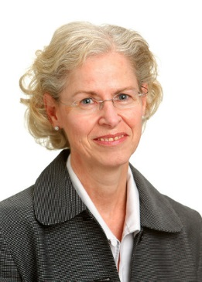**Nancy Hayter**

Nancy Hayter is Executive Director of Research Services, Dalhousie University. Nancy joined Dalhousie in 1987 first as a student and then as an employee. Nancy worked for the international projects unit while completing an undergraduate honours degree in English and a masters degree in Social Anthropology. In 2005, Nancy moved to Research Services. Previous to Dalhousie, Nancy worked for a number of years in radio promotions in Calgary, Alberta.

In her current position as Executive Director, Research Services, Nancy oversees external research funding programs and awards. She is the university contact for several federal granting agencies including the Canada Foundation for Innovation (CFI).

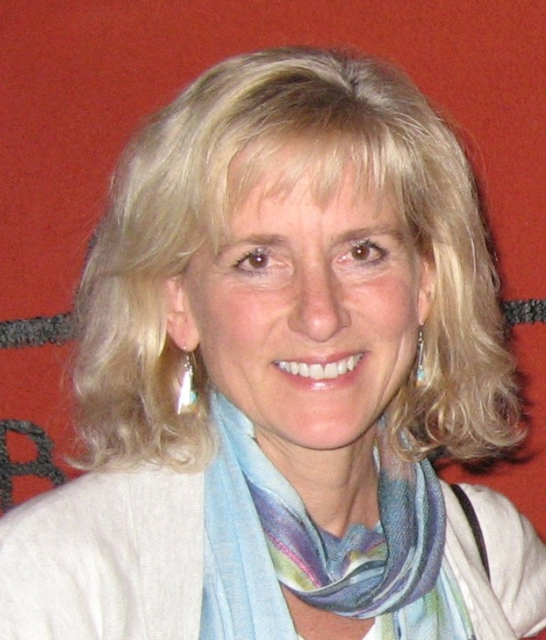**Dr. Sara Iverson**

Dr. Sara Iverson is the Scientific Director of the Ocean Tracking Network (OTN), both the international joint venture component, funded by the Canadian Foundation for Innovation (CFI), and the 7-year OTN Canada Research Network, funded by the Natural Sciences and Engineering Research Council (NSERC).

She is a professor in the Department of Biology at Dalhousie University and currently holds the title of University Research Professor for distinction in scholarship; she is also a former NSERC E.W.R. Steacie Fellow. Sara received her BSc from Duke University and conducted her PhD in comparative physiological ecology jointly at the Smithsonian Institution in Washington DC and the University of Maryland.

Sara’s primary research focus is understanding how animals adapt to and exploit their environments, and the physiological and biochemical mechanisms that constrain or provide opportunities for them to do so. Her research program uses a suite of tools ranging from biochemical tracers to energetic measurements to tracking studies to better understand the biology of marine vertebrates (primarily marine mammals and seabirds) and the food webs within which they function.

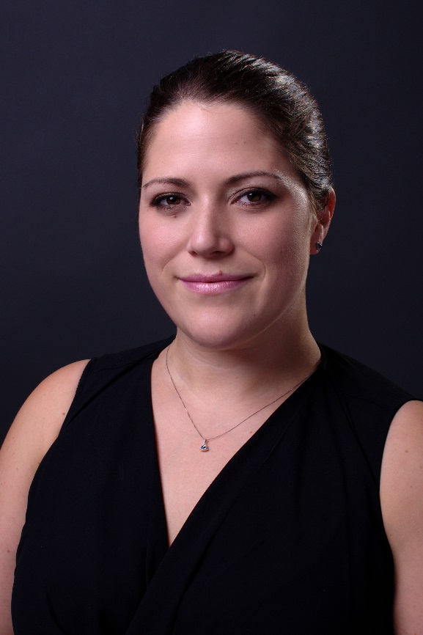**Dr. Kes Morton**

Kes joined the OTN team in June, 2012, and brings a combined background in research and project management. Beginning with a B.Sc. in Ecology from the University of Toronto and a Ph.D. in marine ecology from Memorial University, Kes then moved into private industry and project management of international scientific collaborations.

Most recently, Kes worked for the St. Andrew’s Biological station, and prior managed the FP7 portfolio for a private European company, as well as biological consulting on fish development. Kes also served on the council of the Canadian Society of Ecology and Evolution (CSEE) from 2010-2011.

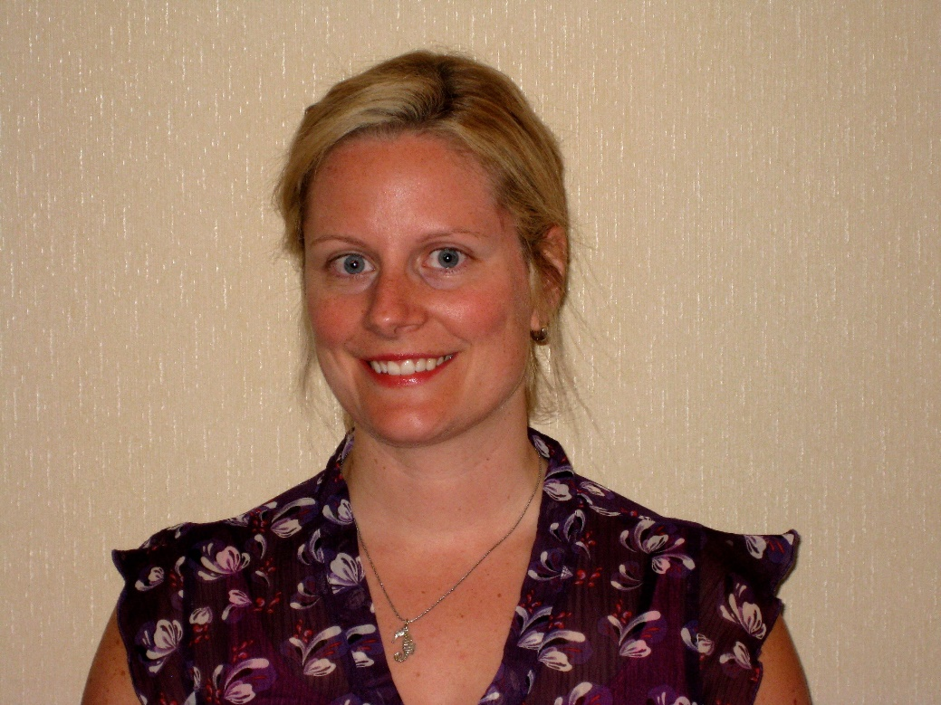**Amy Ryan**

Amy Ryan recently joined the Ocean Tracking Network Canada team in October 2014 as interim Network Manager. She holds Bachelor of Science (Marine Biology/Oceanography combined) and Masters of Marine Management degrees from Dalhousie University in Nova Scotia.

Funded by the Canadian Wildlife Federation, Amy’s masters’ work assessed the role of habitat destruction as a threat to marine species at risk, and evaluated the role and designation of critical habitat as defined by the Species at Risk Act for the conservation of marine species at risk in Canada. Amy presented her work, and won second place for best poster, at the Sustainable Oceans Conference held at Dalhousie University in April 2013. Her undergraduate work involved the quantification of energy content in calanoid copepeods, a staple in the diet of the endangered North Atlantic right whale. The results of this study were published in a manuscript she co-authored entitled “Measured and inferred gross energy content in diapausing Calanus spp. in a Scotian shelf basin.”

For the past two years, Amy has worked as a laboratory technician in Dr. Sara Iverson’s physiological ecology lab conducting lipid analyses on marine and terrestrial vertebrates, the results of which are used to examine species diet and foraging ecology. Amy currently resides in Halifax with her husband and their cat Chloe.

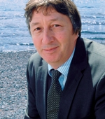**Dr. Douglas Wallace**

Douglas Wallace is a world leader in developing new technologies to measure changes to the world's oceans.

Before becoming Canada Excellence Research Chair in Ocean Science and Technology, Wallace was professor of marine chemistry at the Leibniz Institute of Marine Sciences in Kiel, Germany. There, he also served as deputy director and head of the Marine Biogeochemistry Research Division. He holds a PhD in chemical oceanography from Dalhousie University and a bachelor’s degree in environmental science from the University of East Anglia, United Kingdom.

Wallace spent more than a decade working as a scientist at the prestigious Brookhaven National Laboratory in the United States. He also made significant scientific contributions to his field through the Intergovernmental Panel on Climate Change, and the US Department of Energy, where he developed the first survey to measure the global distribution of fossil-fuel carbon in the oceans.

Wallace is highly skilled at building successful multidisciplinary research teams, including CARBOOCEAN, a five-year study of the ocean carbon cycle, SOLAS, a global project investigating interactions between the atmosphere and the ocean. He also led the development of an ocean and atmosphere observatory on the Cape Verde Islands off the West African coast. Currently, Wallace is also the Scientific Director of the Marine Environmental Observation, Prediction And Response (MEOPAR) Network of Centre of Excellence and the Halifax Marine Research Institute.

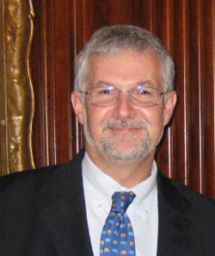**Dr. Fred Whoriskey**

Fred was born and raised in Massachusetts. He graduated from Brown University in Providence, Rhode Island in 1976, and worked for five years at Woods Hole Oceanographic Institution (WHOI) before beginning Ph.D. studies at l’Université Laval in Quebec City.

He graduated in 1984 and held a NATO postdoctoral fellowship at the University College of Wales in Aberystwyth, UK. He was a Professor at McGill University from 1986 – 1995, then joined the Atlantic Salmon Federation in 1995, where he served as Vice President, Research and Environment and responsible for directing the Federation’s science activities until 2010. While at ASF, he developed the organizations sonic tracking programs, which have included work on Atlantic salmon juveniles and adults, American eel, Atlantic cod, and alewives.

Fred's research interests are in fish biology and ecology, and the impacts of exotic species on native ecosystems. He has been heavily involved in public policy issues, especially with regards to environmental impact assessments, and has worked extensively in public education. He received a Gulf of Maine Visionary Award in 2008, and is a frequent public speaker.

Fred served on the Board of AquaNet (Canada’s National Centre of Excellence in Aquaculture), and Chaired the Board of the Huntsman Marine Science Centre. Fred became Executive Director of the Ocean Tracking Network of Dalhousie University in June, 2010.