**Joy Young (Chair)**

Dr. Joy Young brings a holistic approach to understanding the life history and ecology of fishes, specifically as it relates to management. She has an established background in age and growth, genetics, reproduction, movement and parasites of fishes.

Originally from San Diego, California Joy brought her love of good guacamole and fish across the country, working and/or studying in Tennessee, Pennsylvania and the Bahamas before settling on the east coast of Florida. Despite her extensive background in acoustic telemetry dating back to 2002, her doctrate research focused on the role of parasites in egg production of fish. She has organized national symposia on increasing underrepresented minorities in the field of fisheries and guest lectures at Florida high schools and universities on the current and future state of fisheries in Florida.

Her passion is conducting collaborative research using complimentary areas of science to bridge the gap between scientists, managers, and the public. Her work has two main themes: 1. The migration patterns of fishes and their impact on fisheries management and 2. Fostering collaboration and data exchange between researchers using acoustic telemetry. As data manager for the FACT Network, she has built a network of over 63 organizations using acoustic telemetry from the southeastern United States, Bahamas, and Caribbean.

**Alex Hearn**

Alex Hearn is a marine fisheries ecologist who has worked as Professor and Researcher at USFQ and the Galapagos Science Center since 2015. He obtained his BSc in Oceanography and Marine Biology from the University of Southampton, UK; and his MSc and PhD from Heriot-Watt University in the Orkney Islands. He has worked in the Galapagos Islands since 2002 on fisheries research and management and spearheaded the development of the Shark Research Program for the Galapagos Marine Reserve since 2006.

His current projects include using acoustic and satellite telemetry to establish the migratory pathways of whale shark and hammerhead sharks, evaluating the movement ecology of the pelagic assemblage around oceanic islets, and monitoring shark nursery grounds in the Galapagos Marine Reserve. He also continues to publish research on fisheries and fishery management in the Galapagos Islands, in particular related to lobster and sea cucumber resources.

He holds an adjunct position at the University of North Carolina, Chapel Hill; and serves on the Board for the regional MigraMar network.

**Fabrice Jaine**

My first experience with animal telemetry goes back to 2006 when I assisted tagging and tracking movements of white sharks in South Africa. I subsequently acquired broad animal tracking expertise. My PhD research used satellite telemetry to investigate the migratory ecology of manta rays and links to oceanographic processes off east Australia. Later, I gained biologging experience through working as part of the Research & Development team at Customized Animal Tracking Solutions (CATS, [www.cats.is](http://www.cats.is/)) and consulting for the BBC Blue Planet 2 TV-series to design and deploy animal-borne multi-sensor camera setups on various marine species. Over the years I was also involved in several acoustic telemetry projects and gained in-depth knowledge when I joined the Animal Tracking Facility of Australia’s Integrated Marine Observing System (IMOS, [www.imos.org.au](http://imos.org.au/)) in 2016.

My role at IMOS ATF has gradually developed to encompass a range of responsibilities. In addition to coordinating data contributions and requests from partner organizations and research groups, I co-manage (with Xavier Hoenner) the national IMOS Acoustic Tracking Database and the current re-development of the web interface enabling users to access, share and download data. Additionally, I coordinate the current expansion of the IMOS Acoustic Tracking Network (with an additional 5 backbone receiver installations to be rolled out in 2019), participate to field servicing operations and collaborate on projects making use of IMOS ATF data.

**Catherine Jardine**

Catherine Jardine is a Data Analyst at the National Data Center of Canada’s leading ornithological institution; Birds Canada. Her primary projects include NatureCounts (naturecounts.ca), the Canadian node of the Avian Knowledge Network and Canada’s largest repository and sharing portal for bird occurrence data and the Motus Wildlife Tracking Network (motus.org), an automated radio telemetry network with international applications for tracking movements of migratory animals.

In addition, Catherine manages the National Wind Energy Bird and Bat Monitoring Database, and is responsible for the recruitment, standardization and analysis of post-construction monitoring data collected at wind facilities in Canada. During her vacation time Catherine acts as a wildlife guide in British Columbia, South America and Antarctica.

**Reyna Jenkins**

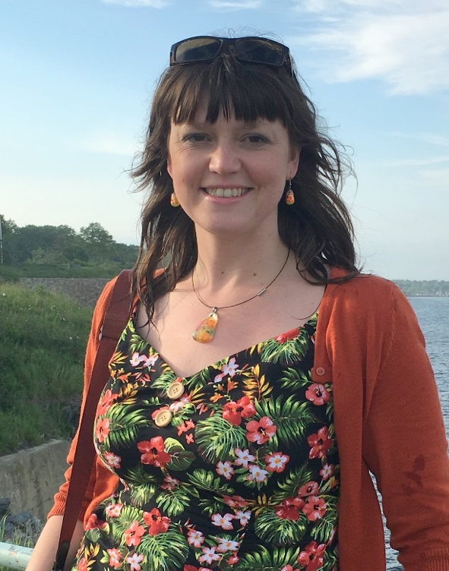Childhood summers spent at Lake Winnipeg, Manitoba instigated a fascination with water and a pride in her Icelandic Canadian heritage. She received her Bachelor of Mathematics in the Applied Mathematics Co-operative Program from the University of Waterloo, with co-op positions in aerospace, environmental consulting and information technology sectors. Her Master of Science in Ocean Physics was supervised by Dr. Eric Kunze at the University of Victoria. Her research area was the transfer of momentum between internal tides and subinertial flow at a dissipating surface reflection. As a graduate student, she had the opportunity to collect oceanographic data on research cruises in coastal BC and the East Pacific Ocean.

Reyna has served Ocean Networks Canada (ONC) since January, 2009. In her initial role as scientific programmer, Reyna generated data products and visuals for the NEPTUNE Canada network. Currently, she leads the Data Stewardship & Operations Support Team responsible for metadata and data curation, geospatial services, data ingestion, and operations support for all the ocean observatories, field expeditions and data partner projects at ONC. In both roles, she has been a keen contributor to Oceans 2.0 tools, web services and interoperability collaborations. Newer developments focus on areas like digital curation of physical samples, data citations, ISO 19115 metadata support and ROV dive video/annotation enhancements.

**Taryn Murray**

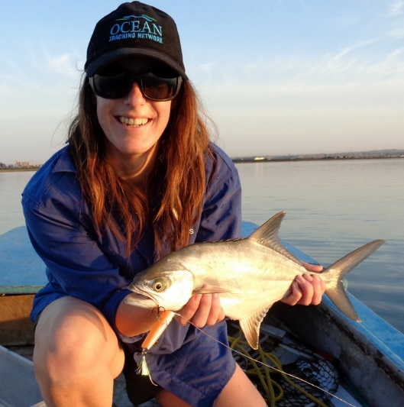Taryn Murray is employed by the South African Institute for Aquatic Biodiversity and has been working as a scientist on the Acoustic Tracking Array Platform (ATAP) since 2017. She obtained her PhD in Ichthyology in 2017 which focused on the movement behaviour of an estuary-dependent carangid and the factors influencing their movements.

Taryn’s research interests are in estuarine ecology, but more specifically, the movement behaviour of estuary-dependent fishery species. It is through this information that one can make informed management decisions, especially in a developing country where more pressure is being placed on estuaries every year.

Taryn’s work experience includes data management of the ATAP – a collaborative marine science programme aiming to provide a service to the greater marine science community in order to monitor the movements and migrations of inshore marine animals. This South African-based platform works in collaboration with the OTN. One of her passions is science communication where she aims to bridge the science-public gap and inform members of the public of ATAP’s work to inspire change. She has also been part of the local organizing committee for the 2nd International Conference on Fish Telemetry, held in Grahamstown, South Africa in 2013, and is actively involved in ATAP’s fieldwork. Her newest projects involve using acoustic telemetry to study the movements of several mullet species in a South African estuary.

**Pieter Provoost**

Pieter Provoost graduated with Master's degrees in Zoology and Marine and Lacustrine Sciences from Ghent University (Belgium) in 2005. He joined the Netherlands Institute of Ecology's Centre for Estuarine and Marine Ecology (NIOO-CEME, now part of the Royal Netherlands Institute for Sea Research NIOZ), where he worked on benthic biogeochemistry, ecosystem modelling, and ocean acidification.

In 2011, Pieter started working as a software engineer in the private sector, until he joined the Ocean Biogeographic Information System (OBIS) as its data manager in 2014. At OBIS, Pieter is responsible for all technical matters, including database management and software development. He also offers technical expertise to other software engineering projects of the Intergovernmental Oceanographic Commission (IOC) of UNESCO. Some of Pieter's professional interests include scaling data systems and improving research reproducibility using open data and R.

**Frank Smith**

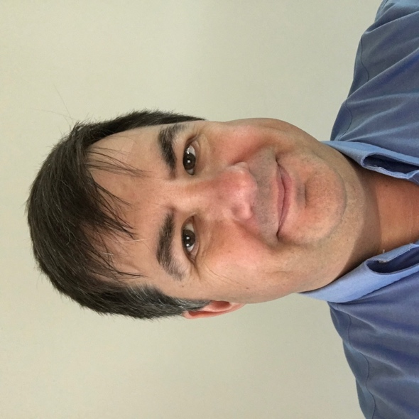Frank graduated with a Master of Computer Science from the Technical University of Nova Scotia in 1992, and has spent 20 of the years since working for VEMCO/AMIRIX. For the past 10 years, his focus has been on the VEMCO Positioning System (VPS), first developing the technology and then building a team to offer VPS processing as a service. More recently Frank has become heavily involved in defining VEMCO’s long-term software and data product roadmap.

**Bill Woodward**

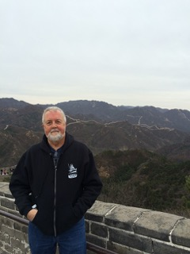Like Fred Whoriskey, Bill was born and raised in Massachusetts. He was selected in April 2016 to be the U.S. Animal Telemetry Network (ATN) Coordinator within the NOAA IOOS Program Office in Silver Spring, MD. Immediately prior to his selection as ATN Coordinator he spent a short time as Director of Business Development for Pacific Gyre, a drifting buoy manufacturer, in Oceanside, California after serving more than 15 years as the President and CEO of CLS America, Inc. At CLS America his duties included, among other things, being responsible for providing satellite tracking service for all No. American Argos Wildlife Programs.

Prior to joining the CLS team, he worked for 28 years in NOAA. With undergraduate and graduate degrees in electrical engineering and ocean engineering, his responsibilities in NOAA included developing and testing ocean instruments and advanced ocean technology, and managing several shipboard and in-situ global ocean and meteorological observation programs. Before joining NOAA, Bill worked at the United States Naval Oceanographic Office’s National Oceanographic Instrumentation Center.

**Lenora Bajona**

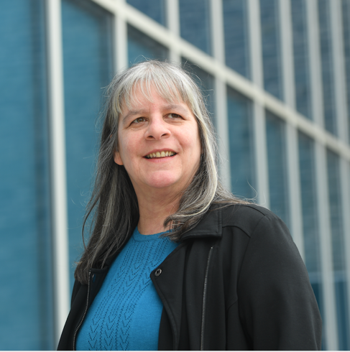Lenore Bajona joined OTN as Portal Manager in June 2010, providing Configuration and Operations Management as part of the Data Management Team. In October of 2014 (formally resigning from DFO) became Director of Data management and as of 2020 Lenore serves as Director of International Data Systems, OTN.

Lenore’s experiences with DFO while Dalhousie, Science COOP student (1991 – 95) led to her joining DFO at Bedford Institute of Oceanography in November 1995. At DFO Lenore’s experience included Informatics Analyst II, 1996-2008, providing computer programming and system analyses for various departments within the Science and Corporate Services Branches. From 2005 – 2010 Lenore’s DFO assignments included 1 year as acting Team Leader (CS03), Data Services (ODIS); 1 year with Population Ecology Division working on Ocean Biodiversity Informatics (Co-chair, Ocean Biodiversity Informatics Conference (OBI’07), held at BIO, Oct. 2 – 4, 2007 (<http://www.marinebiodiversity.ca/OBI07>), providing technical and information management support for OBIS Canada and Centre for Marine Biodiversity, including Taxonomic Standardization and Enrichment (Kennedy, Mary and Lenore Bajona. 2009. A data manager’s guide to marine taxonomic code lists. Can. Tech. Rep. Fish. Aquat. Sci. 2827: iii + 23 p.).

**Jonathan Pye**

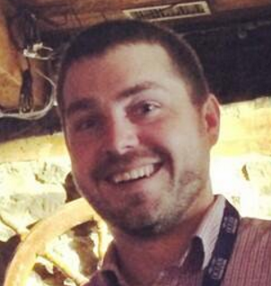Born in Halifax, Nova Scotia, Jon spent his early years on and around the ocean but still hasn’t officially taken a course in biology. He graduated with a Bachelor of Computer Science from Dalhousie University in 2005.

Following this, he worked for the Dalhousie-based Centre for Environmental Ocean Technology Research, storing, combining, and displaying output from real-time reporting buoy systems with the results of field sampling and complex laboratory analysis to characterize the physical, acoustic, and biological characteristics of Lunenburg Bay.

After a brief tour as data manager for an upstart biofuels initiative, Jon re-trained on the operation and deployment of various AUV/UAVs and contemporaneously designed database and web portal systems for storing and displaying this data for the Ocean Tracking Network.

In 2014, Jon joined the OTNDC officially as their new Portal Manager. His interests run from streamlining the ingestion of human-generated data to database scalability in the face of disruptive sampling technology to effective data visualization. His current focus is on packaging and disseminating open source tools to enable researchers to quickly implement the latest techniques in acoustic telemetry analysis on their own datasets, and on packaging the OTN database schema and data management process into database ‘nodes’, to empower the data aspect of existing and nascent telemetry collaborations happening on a regional scale.

**Fred Whoriskey**

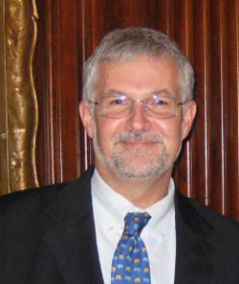Fred was born and raised in Massachusetts. He graduated from Brown University in Providence, Rhode Island in 1976, and worked for five years at Woods Hole Oceanographic Institution (WHOI) before beginning Ph.D. studies at l’Université Laval in Quebec City.

He graduated in 1984 and held a NATO postdoctoral fellowship at the University College of Wales in Aberystwyth, UK. He was a Professor at McGill University from 1986 – 1995, then joined the Atlantic Salmon Federation in 1995, where he served as Vice President, Research and Environment and responsible for directing the Federation’s science activities until 2010. While at ASF, he developed the organizations sonic tracking programs, which have included work on Atlantic salmon juveniles and adults, American eel, Atlantic cod, and alewives.

Fred's research interests are in fish biology and ecology, and the impacts of exotic species on native ecosystems. He has been heavily involved in public policy issues, especially with regards to environmental impact assessments, and has worked extensively in public education. He received a Gulf of Maine Visionary Award in 2008, and is a frequent public speaker.

Fred served on the Board of AquaNet (Canada’s National Centre of Excellence in Aquaculture) and Chaired the Board of the Huntsman Marine Science Centre. Fred became Executive Director of the Ocean Tracking Network of Dalhousie University in June, 2010.