OTN - Project Plan

Name of Array
Date of submission

Background

Please provide background information about the study, including:
- Scientific objectives (hypotheses tested, questions asked, species monitored)
- Scientific merit/excellence of the research team
- Potential benefits to fisheries management, ocean conservation, user groups, etc.
- Previous telemetry in the region including range testing.

Funding

Please indicate the budget for the project, including funding sources for operation costs, and whether the funding is confirmed or anticipated. If anticipated, please indicate the expected date of notification.

Initial Array Design
- Equipment and Services: please update based on project
    - Dalhousie will provide:
      - XX acoustic receivers: with lithium batteries;
    - partner will provide:
      - <Ship time>
      - <Qualified personnel for deployment>
      - <Boat time for maintenance and uploading of data>.
      - <Replacement batteries for acoustic receivers>.
      - <Other>

- Proposed Line Location:

Sample text: The <array name here> will be located <general description of the array with reference to any well-known landmarks>. The line is composed of <X> stations (See maps below). Details of the deployment geometry (spacing between stations and depth of receivers) are for illustrative purpose as changes might be required upon analysis of the test phase data.

Sample map: Please update with map for proposed receiver locations for this project
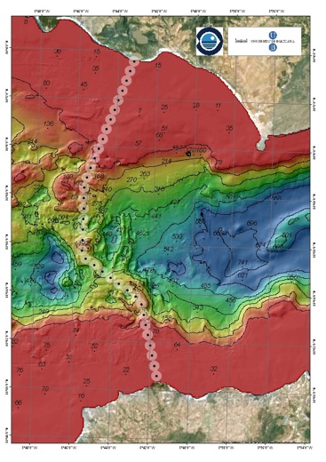
- Bathymetric Information:
This section should provide any available information on bathymetry, including maps when possible.
- Proposed Receiver Locations:
  - These proposed receiver locations are approximations and are subject to change.
  - This information can be keyed into this spreadsheet (https://members.oceantrack.org/data/data-collection) and attached to this project plan or copy and pasted below.

Deployment Schedule

The deployment of the <X> acoustic receivers is planned for <relative timeframe. exact dates not required>. Final details of the deployment schedules are still being reviewed and will depend on vessel availability and weather conditions.

Maintenance Schedule

It is expected that service trips to the <name of the array> will take place <frequency of trips (at a minimum must be once a year)>, at which time batteries will be changed and biofouling will be removed.

Data Retrieval Schedule

Data will be uploaded from the receivers at minimum once a year and submitted to OTN in the manner outlined in the OTN Data Management Policy.

Mooring Design

This section should provide details of the mooring design. Please include the following:
- Description of substrate.
- Types and quantities of materials used (rope, chain, shackles, etc.).
- Anchor material (concrete or metal) and weight (if applicable).
- Floatation material (plastic, foam, synthetic foam, etc.).
- Recovery plan (acoustic release vs. diving. vs. grappling, etc.).
- A sketch or image of the mooring.
- Previous literature/examples of success using this mooring design.

Tagging Plan
This section should provide details of the tagging plan, where required. Please include the following:
- Number, type, and power of tags.
- Tagging method (external tagging, internal surgical tagging, etc.).
- Method of acquiring target species.
- Animal care protocols (water hose, holding/recovery tank, anesthesia, etc.).
- Previous literature/examples of success using this tagging method.

Risk Management

Please identify any potential risks to the project and how they might be managed, as they fit into the following categories:

Type of risk | Potential risks | Management of risk
Technical/ Environmental*
Financial
Political
Safety/Field Experience
*If your region is subject to sudden/extreme weather events (storms, hurricanes, etc.), please ensure to make note of these risks and include insights on a mitigation plan in place. As part of the loan agreement, the partners are responsible for ensuring, to the best of their abilities, the gear is not damaged or lost.

Authorization:

Institution Name:

Principal Investigator:

Title:

Signature:

Date:

