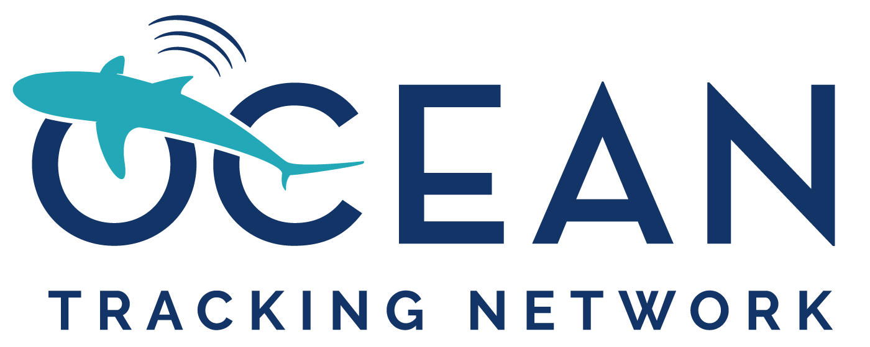

Ocean Tracking Network
Application for an equipment loan

Introduction

The Ocean Tracking Network (OTN) is a Canada Foundation for Innovation (CFI) – Major Science Initiative Fund global research and technology development project headquartered at Dalhousie University, Halifax, Nova Scotia. Since 2008, OTN has been deploying state-of-the-art acoustic receivers and marine autonomous vehicles in key aquatic locations across the globe. The knowledge generated on the movements and survival of aquatic animals by OTN, in partnership with the global network (~400 international researchers from 37 countries), is used to help guide management decisions and the sustainable use of aquatic systems.

As part of its mandate to foster high-quality telemetry science, and grow and maintain a global network of acoustic monitoring equipment, OTN operates an equipment loaner program. These loans primarily consist of Vemco receiver units, and are granted to a variety of organizations including universities, government agencies, industry, and non-governmental organizations. A typical loan period starts at two years, with opportunity for extension. Longer loans are possible on a case-by-case basis.

In addition to equipment loans, OTN hosts a data warehouse that serves as a repository for data collected by OTN researchers, and is working to develop interpretation and visualization tools for tracking data. Additional information on OTN can be found at http://oceantrackingnetwork.org/.

Criteria for the loan:

Applications will be evaluated based on:

- The scientific merit of the proposal and its relevance to the mission and science objectives of OTN
- The study design, configuration of the array, and risk management plan
- The potential for the deployment to foster connectivity with other telemetry researchers in the region, and to assist with growing the collaborative network

Application procedure

Prior to making an application, interested researchers should contact oceantrackingnetwork@dal.ca to determine availability of equipment for loan and discuss their potential application. Suitable projects will be invited to submit a copy of the application form and a project plan. The application is subject to a peer review process by a Deployment Committee composed of subject-matter experts to determine final approval. There is no deadline for applications, but fulfilment is subject to equipment availability. Please note the review and approval process for larger loan request (>5 units) can take up to 3 months so applicants should plan for this when submitting their application. OTN will make available to successful applications the services of our technical team to assist with the design and review of mooring systems for the proposed work. In some instances, OTN may be able to send a member of our technical team to assist with field work on the projects.

Application for an equipment loan from OTN

Applicant Information:

Name: Click or tap here to enter text.
Title: Click or tap here to enter text.
Address to receive loaned equipment: Click or tap here to enter text.
EIN/Tax ID (US Only): Click or tap here to enter text.
EORI # (EU, Northern Ireland, Norway, Switzerland): Click or tap here to enter text.
Email: Click or tap here to enter text.
Telephone number: Click or tap here to enter text.
Applicant Responsibilities:

- Comply with all relevant customs procedures, including paying for any customs duties.
- Pay for return shipping costs, operations and maintenance expenses (including battery replacement) necessary to deploy and maintain the receivers for the duration of the agreement.
- Provide a copy of the instrument metadata, detection data (ex: VRL receiver files) from the equipment and any associated receivers used in the study, as well as tagging metadata for all animals tagged in support of the study, within three months of the collection of the data, to the OTN data warehouse.
- Abide by the OTN data policy, found here.
- Notify OTN of any lost, failed, or damaged receivers via email (otndc@dal.ca) as soon as the information is known and report this status within the instrument metadata.
- Sign/coordinate the signing of the equipment loan agreement between OTN and the applicant’s institution.
- Acknowledge OTN in all publications, presentations, or other materials relating to the project.
- Upon request, provide an updated project plan and progress report at the time of loan agreement renewal.
- Complete the OTN Annual Report survey circulated in April of each year.
Note: survey participation is essential to ensuring OTN can maintain funding for this equipment loan program. This information will be used in our various reports, including the annual report to our funders, and possibly in occasional releases to media outlets on OTN activities.

The latest versions of OTN operational policies, templates and checklists for data collection are available online at: https://members.oceantrack.org/data/data-collection.

I have read and am committing to the responsibilities assigned to me as the applicant.

Applicant signature: __________________________________________________

Proposed Collaborator Information (add additional names if required):

Present status (Check one)

#1 Name: Click or tap here to enter text. PhD PostDoc Technician
Institution: Click or tap here to enter text. Student:PhD MSc Undergrad
Email address: Click or tap here to enter text.
ORCID: Click or tap here to enter text.
#2 Name: Click or tap here to enter text. PhD PostDoc Technician
Institution: Click or tap here to enter text. Student: PhD MSc Undergrad
Email address: Click or tap here to enter text.
ORCID: Click or tap here to enter text.
#3 Name: Click or tap here to enter text. PhD PostDoc Technician
Institution: Click or tap here to enter text. Student: PhD MSc Undergrad
Email address: Click or tap here to enter text.
ORCID: Click or tap here to enter text.
#4 Name: Click or tap here to enter text. PhD PostDoc Technician
Institution: Click or tap here to enter text. Student: PhD MSc Undergrad
Email address: Click or tap here to enter text.
ORCID: Click or tap here to enter text.
Study title: Click or tap here to enter text.

Number and type of receivers requested: Click or tap here to enter text.

Number of acoustic receivers which are already on hand to supplement OTN equipment: Click or tap here to enter text.

Minimum number of OTN receivers required for project to proceed (If request is >10): Click or tap here to enter text.

Proposed location of deployment
- Country and region: Click or tap here to enter text.
- Latitude and longitude: Click or tap here to enter text.

Proposed period of deployment
- Start: Click or tap here to enter text.
- End: Click or tap here to enter text.

Latest date equipment can be received: Click or tap here to enter text.

Species to be studied: Click or tap here to enter text.

Are you affiliated with any regional telemetry networks? If applicable, please indicate below.
Acoustic Tracking Array Platform (ATAP)
FACT Network
OTN-Brazil
MIGRAMAR
Atlantic Cooperative Telemetry Network (ACT)
European Tracking Network (ETN)
Integrated Marine Observing System (IMOS)
Great Lakes Acoustic Telemetry Observation System (GLATOS)
Other (please specify): Click or tap here to enter text.
Are there other telemetry arrays in the region of your study on which your animals might be detected? If yes, how will your project complement ongoing telemetry research in your study area? Please indicate the relevant network contacts and specify whether they will be contacted regarding your study. Are there associated projects in any other telemetry networks (FACT, ETN etc)?

Click or tap here to enter text.

Have you or any members of you team had previous experience with sonic telemetry? Please describe this briefly.

Click or tap here to enter text.

Which code set (i.e., MAP 114) do you use?

Click or tap here to enter text.

Shipping Details
Dalhousie University will cover costs of shipping the equipment to <location where equipment will be shipped/delivered>. Dalhousie will ensure that the acoustic receivers are in good working order and condition before they are shipped. Dalhousie is not responsible for any costs associated with customs/import/ charges (see applicant responsibilities above). Please be knowledgeable on expected charges for receiving the equipment.
Please provide the complete shipping address.
Name Click or tap here to enter text.
Shipping Address Click or tap here to enter text.
EIN/Tax ID Number (US only) Click or tap here to enter text.
Email Click or tap here to enter text.
Telephone number Click or tap here to enter text.
For shipments outside of North America, please answer the following questions:
Are you aware of any limitations of bringing dangerous goods into the country?
Click or tap here to enter text.
Have you brought dangerous goods (i.e., lithium batteries) into the country before? Click or tap here to enter text.
Do you have a preferred carrier? If so, please specify. Click or tap here to enter text.
Broker information:
If applicable, please provide the name and contact information for your broker, including email address, fax, telephone number and any additional shipping details that may be helpful.

Name Click or tap here to enter text.

Email Click or tap here to enter text.

Fax Click or tap here to enter text.

Telephone Click or tap here to enter text.

Additional information Click or tap here to enter text.

Append a completed Project Plan template, describing the proposed use and deployments of the equipment.

