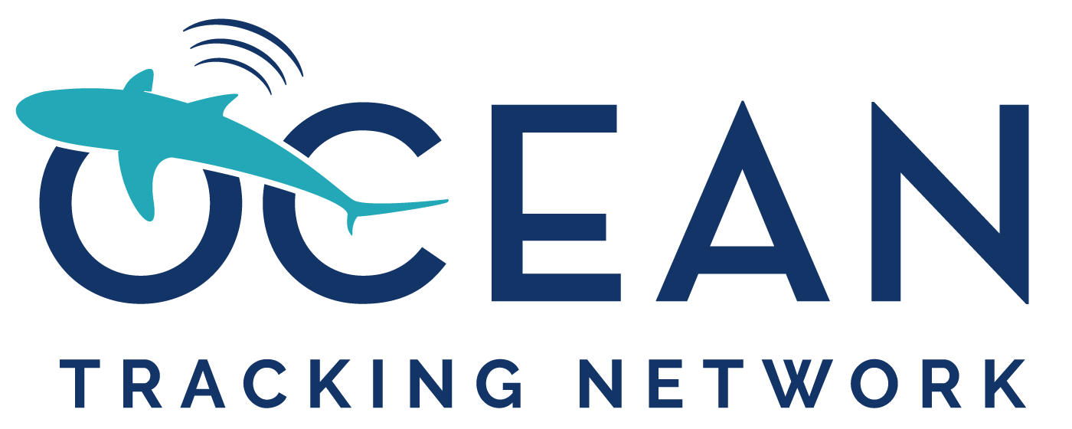

Ocean Tracking Network
Application for an equipment loan

Introduction

The Ocean Tracking Network (OTN) is a global aquatic research, data management, and partnership platform headquartered at Dalhousie University in Halifax, Canada. OTN’s mission is to inform the stewardship and sustainable management of aquatic animals by generating knowledge on their movements, habitats, and survival in the face of changing environments. Knowledge generated by OTN and its collaborators is used locally, nationally, and internationally to help guide the management of aquatic species and the sustainable use of ocean and freshwater resources.
OTN operates a no-cost equipment loaner program to support high quality telemetry science around the world. These loans primarily consist of Innovasea receiver units and are granted to organizations in all sectors, including universities, government agencies, industry, and non-governmental organizations. A typical loan period starts at two years, with opportunity for extension.

In addition to equipment loans, OTN hosts an internationally certified data warehouse that serves as the repository for data collected by OTN researchers. OTN staff also support the development of interpretation and visualization tools for tracking data. Additional information on OTN can be found at http://oceantrackingnetwork.org/.
OTN is funded primarily by the Canada Foundation for Innovation.

Criteria for the loan:

Applications will be evaluated based on:

- The scientific merit of the proposal and its relevance to the mission and science objectives of OTN
- The study design, configuration of the array, and risk management plan
- The potential for the deployment to foster connectivity with other telemetry researchers in the region, and to assist with growing the collaborative network

Application procedure

Prior to making an application, interested researchers should contact oceantrackingnetwork@dal.ca to determine availability of equipment for loan and discuss their potential application. Suitable projects will be invited to submit a copy of the application form and a project plan. The application is subject to a peer review process by a Deployment Committee composed of subject-matter experts to determine final approval. There is no deadline for applications, but fulfilment is subject to equipment availability. Please note the review and approval process for larger loan request (>5 units) can take up to 3 months so applicants should plan for this when submitting their application. OTN will make available to successful applications the services of our technical team to assist with the design and review of mooring systems for the proposed work. In some instances, OTN may be able to send a member of our technical team to assist with field work on the projects.

Application for an equipment loan from OTN

Applicant Information:

Name: Click or tap here to enter text.
Position: Click or tap here to enter text.
Address: Click or tap here to enter text.
Email: Click or tap here to enter text.
Telephone number: Click or tap here to enter text.
Applicant Responsibilities:

- Comply with all relevant customs procedures, including paying for any customs duties.
- Pay for return shipping costs, operations and maintenance expenses (including battery replacement) necessary to deploy and maintain the receivers for the duration of the agreement.
- Provide a copy of the instrument metadata, detection data (ex: VRL receiver files) from the equipment and any associated receivers used in the study, as well as tagging metadata for all animals tagged in support of the study, within three months of the collection of the data, to the OTN data warehouse.
- Abide by the OTN data policy, found here.
- Notify OTN of any lost, failed, or damaged receivers via email (otndc@dal.ca) as soon as the information is known and report this status within the instrument metadata.
- Notify OTN if the project is no longer proceeding or if the deployment timeline has been delayed as soon as this information is known.
- Sign/coordinate the signing of the equipment loan agreement between OTN and the applicant’s institution.
- Acknowledge OTN in all publications, presentations, or other materials relating to the project.
- Upon request, provide an updated project plan and progress report at the time of loan agreement renewal.
- Complete the OTN Annual Report survey circulated in April of each year.
Note: survey participation is essential to ensuring OTN can maintain funding for this equipment loan program. This information will be used in our various reports, including the annual report to our funders, and possibly in occasional releases to media outlets on OTN activities.

The latest versions of OTN operational policies, templates and checklists for data collection are available online at: https://members.oceantrack.org/data/data-collection.

I have read and am committing to the responsibilities assigned to me as the applicant.

Applicant signature: __________________________________________________

Please check this box if you'd like to sign up for OTN's e-list, which provides important updates about the organization, the latest news, and event details approximately 4-5 times per year. You can unsubscribe at any time.

Proposed Collaborator Information (add additional names if required):

Present status (Check one)

#1 Name: Click or tap here to enter text. PhD PostDoc Technician
Institution: Click or tap here to enter text. Student:PhD MSc Undergrad
Email address: Click or tap here to enter text.
ORCID: Click or tap here to enter text.
#2 Name: Click or tap here to enter text. PhD PostDoc Technician
Institution: Click or tap here to enter text. Student: PhD MSc Undergrad
Email address: Click or tap here to enter text.
ORCID: Click or tap here to enter text.
#3 Name: Click or tap here to enter text. PhD PostDoc Technician
Institution: Click or tap here to enter text. Student: PhD MSc Undergrad
Email address: Click or tap here to enter text.
ORCID: Click or tap here to enter text.
#4 Name: Click or tap here to enter text. PhD PostDoc Technician
Institution: Click or tap here to enter text. Student: PhD MSc Undergrad
Email address: Click or tap here to enter text.
ORCID: Click or tap here to enter text.
Study title: Click or tap here to enter text.

Number and type (VR2W, VR2AR, VR2Tx) of receivers requested: Click or tap here to enter text.

OTN has a limited number of receivers that have been upgraded to Open Protocol. Do you require OP receivers? If yes, please provide a brief rationale on why they are needed: Click or tap here to enter text.

Number of acoustic receivers which are already on hand to supplement OTN equipment: Click or tap here to enter text.

Minimum number of OTN receivers required for project to proceed (If request is >10): Click or tap here to enter text.

Proposed location of deployment
- Country and region: Click or tap here to enter text.
- Latitude and longitude: Click or tap here to enter text.

Proposed period of deployment
- Start: Click or tap here to enter text.
- End: Click or tap here to enter text.

Latest date equipment can be received: Click or tap here to enter text.

Species to be studied: Click or tap here to enter text.

Are you affiliated with any regional telemetry networks? If applicable, please indicate below.
Acoustic Tracking Array Platform (ATAP)
FACT Network
OTN-Brazil
MIGRAMAR
Atlantic Cooperative Telemetry Network (ACT)
European Tracking Network (ETN)
Integrated Marine Observing System (IMOS)
Great Lakes Acoustic Telemetry Observation System (GLATOS)
North Pacific Acoustic Telemetry (N-PAcT)
Other (please specify): Click or tap here to enter text.

Are there other telemetry arrays in the region of your study on which your animals might be detected? If yes, how will your project complement ongoing telemetry research in your study area? Please indicate the relevant network contacts and specify whether they will be contacted regarding your study. Are there associated projects in any other telemetry networks (FACT, ETN etc)?

Click or tap here to enter text.

Have you or any members of you team had previous experience with sonic telemetry? Please describe this briefly.

Click or tap here to enter text.

Which code set (i.e., MAP 114) do you use?

Click or tap here to enter text.

Shipping Details
Dalhousie University will cover costs of shipping the equipment to <location where equipment will be shipped/delivered>. Dalhousie will ensure that the acoustic receivers are in good working order and condition before they are shipped. Dalhousie is not responsible for any costs associated with customs/import/ charges (see applicant responsibilities above). Please be knowledgeable on expected charges for receiving the equipment.
Please note: Unless otherwise requested, the loaned receivers will be shipped to you with batteries in them. Lithium metal D/DD-cell batteries are classified as Dangerous Goods and must be handled according to UN Recommendations on the Transport of Dangerous Goods (UN3090 for batteries alone; UN3091 for batteries contained in equipment or packed with it). See the MSDS from the battery company for more information. In the event of a Dangerous goods emergency, call CANUTEC’s 24-hour number: 1-888-CAN-UTEC (226-8832), 613-996-6666 or *666 on a cellular phone.
Please provide the complete shipping address.
Name Click or tap here to enter text.
Shipping Address Click or tap here to enter text.
Tax ID Number (US only) Click or tap here to enter text.
EORI/ EIN # (EU, Northern Ireland, Norway, Switzerland): Click or tap here to enter text.
Email Click or tap here to enter text.
Telephone number Click or tap here to enter text.
For shipments outside of North America, please answer the following questions:
Are you aware of any limitations of bringing dangerous goods into the country?
Click or tap here to enter text.
Have you brought dangerous goods (i.e., lithium batteries) into the country before? Click or tap here to enter text.
Do you have a preferred carrier? If so, please specify. Click or tap here to enter text.
Confirm if you would like batteries included in your requested units. Click or tap here to enter text.

Broker information:
If applicable, please provide the name and contact information for your broker, including email address, fax, telephone number and any additional shipping details that may be helpful.

Name Click or tap here to enter text.

Email Click or tap here to enter text.

Fax Click or tap here to enter text.

Telephone Click or tap here to enter text.

Additional information Click or tap here to enter text.

Append a completed Project Plan template, describing the proposed use and deployments of the equipment.



